
- Faculty of Artificial Intelligence and Data Science
- Software Engineering
- Smart Home Automation System Using AI
- Shahd shalaldeh
- Dania manasrah
- Dr. Ahmad Hassasneh
- April 2026

Abstract
This project presents the design and implementation of a smart home automation system using Artificial Intelligence (AI). The main problem addressed in this project is the lack of efficient, adaptive, and user-friendly home control systems that can respond intelligently to user needs and environmental changes.

The proposed solution is to develop an AI-based system that automates and controls various home devices such as lighting, heating, security systems, and appliances. The system utilizes machine learning algorithms and sensors to analyze user behavior and make intelligent decisions, allowing for real-time automation and remote control through mobile or web applications.

The expected results of this project include improved energy efficiency, enhanced security, increased user comfort, and reduced human effort in managing household tasks. Additionally, the system aims to provide a scalable and cost-effective solution that can be adapted to different types of homes and user preferences.

In conclusion, this project demonstrates how integrating AI technologies into home automation can significantly improve the quality of life and contribute to the development of smart and sustainable living environments.

Table of Contents

Cover Page ............................................... i
Abstract ................................................. ii

List of Figures .......................................... iii

Chapter One: Introduction ................................. 1
1.1 Introduction .......................................... 2
1.2 Problem Statement ..................................... 3
1.3 Project Objectives .................................... 4
1.4 Project Benefits ...................................... 5
1.5 Project Constraints ................................... 6
1.6 Proposed Methodology .................................. 7
1.7 Project Time Plan ..................................... 8
1.8 Feasibility Study ..................................... 9
1.9 Summary and Recommendations ........................... 10

Chapter Two: Software Specification ....................... 11
2.1 Introduction .......................................... 12
2.2 Functional Requirements ............................... 13
2.3 Non-Functional Requirements ........................... 14
2.4 Software Specification ................................. 15
2.5 Summary and Recommendations ........................... 16

Chapter Three: Software Design ............................ 17
3.1 Introduction .......................................... 18
3.2 Context Diagram ....................................... 19
3.3 Use Case Diagram ...................................... 20
3.4 Activity Diagrams ..................................... 21
3.5 Sequence Diagrams ..................................... 22
3.6 Class Diagram ......................................... 23
3.8 Summary and Recommendations ........................... 24

List of Figures :
- Figure 0 Project Timeline
- Figure 1 Context Diagram of the Smart Home Automation System Using AI
- Figure 2 Smart Home Automation System Using AI use case diagram
- Figure 3 Activity Diagram-User Registration and Login
- Figure 4 Activity Diagram- Devise Management
- Figure 5 Activity Diagram-Manual and AI-Based Lighting Control
- Figure 6 Activity Diagram-Manual and Ai Temperature Control
- Figure 7 Activity Diagram for AI-Based Security Monitoring
- Figure 8 Activity Diagram for AI-Based Voice Command Support
- Figure 9 Activity Diagram for Fire Emergency Management Using AI
- Figure 10 Activity Diagram for AI-Based Energy Monitoring
- Figure 11 Activity Diagram for AI-Based Reports Generation
- Figure 12 Sequence Diagram for User-Controlled Lighting
- Figure 13 Sequence Diagram for Voice Assistant - Control Devices
- Figure 14 Sequence Diagram for AI System - Smart Decision Making and User - Receive Alerts/Notification.
- Figure 15 Sequence Diagram for User - Generate Reports.
- Figure 16 class diagram for the Smart Home Automation System Using AI .

1.1 Introduction

With the rapid advancement of technology, smart home systems have become an important part of modern living. These systems aim to improve comfort, security, and energy efficiency by allowing users to control and monitor home devices remotely. As people rely more on automation, integrating intelligent solutions into daily life has become increasingly valuable.

This project presents a Smart Home Automation System using Artificial Intelligence, which allows users to control devices such as lights, doors, and temperature systems through a mobile application. The system provides both manual control and automated features that respond to user behavior and environmental conditions, making the home more efficient and user-friendly.

The project also focuses on applying Software Engineering principles, including requirement analysis, system design, and testing, while following an Agile development approach. The goal is to develop a practical and scalable system that reflects real-world smart home solutions and enhances the overall user experience.

1.2 Problem Statement

In recent years, the demand for smart home systems has increased significantly. However, many existing home automation systems are limited in functionality, lack intelligence, and require manual control or complex user interaction. These systems often do not adapt to user behavior or environmental changes, which reduces their efficiency and usability.

Additionally, traditional home systems consume a large amount of energy due to the absence of smart decision-making mechanisms. Security is also a concern, as many systems do not provide advanced monitoring or real-time response to potential threats.

Therefore, there is a need to develop an intelligent smart home automation system using Artificial Intelligence that can learn from user behavior, make autonomous decisions, improve energy efficiency, enhance security, and provide a more comfortable and user-friendly experience.

1.3 Project Objectives

The main objectives of the Smart Home Automation System using AI are:
- To design and develop an intelligent smart home system that automates household devices efficiently.
- To improve user comfort by enabling remote and automatic control of home appliances.
- To enhance energy efficiency by optimizing the usage of electricity and reducing waste.
- To increase home security through smart monitoring and real-time alerts.
- To implement an AI-based system capable of learning user behavior and making intelligent decisions.
- To provide a user-friendly interface that allows easy interaction with the system via mobile or web applications.
- To develop a scalable system that can be expanded and integrated with different smart devices.

1.4 Project Benefits

Benefits for Users:
- Provides greater comfort by allowing automatic and remote control of home devices.
- Saves time and effort by reducing the need for manual operation of household systems
- Improves energy efficiency, which helps reduce electricity bills.
- Enhances home security through smart monitoring and instant alerts.
- Offers a personalized experience by adapting to user habits and preferences.
- Provides an easy-to-use interface accessible via mobile or web applications.

Benefits for Society:
- Contributes to the development of smart cities and modern living environments.
- Promotes energy conservation, which helps reduce environmental pollution.
- Encourages the use of Artificial Intelligence in everyday life applications.
- Improves overall safety standards in residential areas.
- Supports technological advancement and innovation in the field of IoT and AI systems.

1.5 Project Constraints

The Smart Home Automation System using AI may face several constraints and limitations, including:
- Limited budget for hardware components such as sensors, controllers, and smart devices.
- Time constraints, as the project must be completed within a fixed academic schedule.
- Technical limitations in implementing advanced AI models or real-time processing.
- Dependency on stable internet connection for remote control and cloud-based features.
- Limited access to real smart home devices for full-scale testing and validation.
- Security and privacy concerns related to collecting and processing user data.
- Lack of large datasets for training machine learning models effectively.

1.6 Proposed Methodology

Agile Methodology
We chose the Agile methodology for the Smart Home Automation Using AI project because the project involves multiple components such as smart sensors, artificial intelligence models, device control, and user interfaces. These components require continuous development, testing, and improvement throughout the project lifecycle.

Agile allows the project to be divided into small development cycles (Sprints), where each sprint focuses on implementing a specific feature, such as sensor integration, AI-based decision making, security functions, or mobile application development. After each sprint, the team evaluates the results and makes necessary improvements based on feedback and testing outcomes.

This methodology was selected because it provides flexibility to accommodate changing requirements, improves collaboration among team members, enables early detection of problems, and ensures the delivery of a high-quality system. Since AI systems often require repeated training and optimization, Agile is particularly suitable because it supports iterative development and continuous enhancement of system performance.

The development of the Smart Home Automation System using AI will follow a structured approach to ensure efficient design and implementation. The proposed methodology includes the following stages:
- Requirement Analysis:
Collect and analyze system requirements by identifying user needs and defining the main functions of the smart home system.
- System Design:
Design the overall architecture of the system, including hardware components (sensors and devices) and software components (AI algorithms and user interface).
- Data Collection:
Gather relevant data from sensors or simulated environments to support the AI model in learning user behavior and environmental patterns.
- AI Model Development:
Develop and train machine learning models to enable intelligent decision-making, such as controlling lighting, temperature, and security systems.
- Implementation:
Integrate hardware and software components to build the complete system, including mobile or web application for user interaction.
- Testing and Evaluation:
Test the system under different scenarios to ensure accuracy, performance, reliability, and security.
- Deployment and Maintenance:
Deploy the system for use and perform continuous updates and improvements based on user feedback.


Figure 0 Project Timeline

1.8 Project Feasibility Study :

The feasibility study evaluates the practicality of developing the Smart Home Automation System using AI from different perspectives, including economic, technical, legal, and time feasibility.

1. Economic Feasibility

The project is considered economically feasible because it can be developed using low-cost or simulated hardware and open-source software tools. Although smart devices and sensors may be expensive, simulation tools and software-based implementation reduce the overall cost significantly.

2. Technical Feasibility

The project is technically feasible as it can be implemented using widely available technologies such as Python, machine learning libraries, IoT platforms, and web or mobile development frameworks. However, developing advanced AI features may require moderate technical expertise.

3. Legal Feasibility

The project is legally feasible as it does not violate any laws. However, data privacy must be considered when handling user data, ensuring that all information is stored and processed securely and ethically.

4. Time Feasibility

The project is time feasible because it can be completed within an academic semester using a structured timeline. Proper planning and phased development ensure that all tasks can be completed within the given deadline.
1.9 Summary

In this chapter, the main aspects of the Smart Home Automation System using AI were discussed. The introduction presented the importance of developing intelligent systems to improve home management and user comfort. The problem statement highlighted the limitations of traditional home systems, such as lack of automation, low efficiency, and limited security features.

The project objectives were defined to focus on building an intelligent system capable of automating home devices, improving energy efficiency, enhancing security, and providing a user-friendly experience. The benefits of the project were also explained for both users and society, showing how the system can improve daily life and contribute to smart living environments.

In addition, the constraints, methodology, time plan, and feasibility study were presented to explain the limitations, development approach, schedule, and practicality of the project.

Overall, this chapter provides a clear foundation for the development of the Smart Home Automation System using AI and prepares for the next stages of system specification and design.

2.1 Introduction
With the rapid advancement of Artificial Intelligence (AI) and Internet of Things (IoT) technologies, smart home systems have become one of the most important innovations in modern living. These systems aim to enhance comfort, security, and energy efficiency by enabling intelligent control and automation of household devices. Through interconnected sensors, smart devices, and communication technologies, users can monitor and manage their homes remotely and efficiently.
The Smart Home Automation System Using AI is designed to provide an intelligent environment that allows users to control various home appliances, lighting systems, temperature settings, and security devices through a centralized platform. By integrating AI techniques, the system can analyze user behavior, learn usage patterns, and make automated decisions that improve the overall user experience while minimizing manual intervention.
In addition to convenience, the system contributes to energy conservation by optimizing the operation of connected devices based on real-time conditions and user preferences. It also enhances home security by continuously monitoring sensors and generating instant alerts when unusual activities are detected. These features make the system more adaptive, reliable, and efficient compared to traditional home management approaches.
This chapter presents the software specifications of the proposed system, including its functional and non-functional requirements. It also provides an overview of the system’s features, behavior, and overall capabilities to ensure that it meets user needs effectively and efficiently.
2.2 Functional Requirements
1: User Registration and Login
The system shall allow users to create accounts and log in securely. Users can register by providing their personal information and creating login credentials. The system shall authenticate users before granting access and ensure that all user data and login sessions are protected through secure authentication mechanisms.

2: Device Management
The system shall allow users to add, remove, update, and manage smart home devices. Users can connect new devices to the system, modify device settings, organize devices into categories, and monitor the status of all connected devices through a centralized dashboard.

3: Smart Lighting Control
The system shall enable users to turn lights on/off and adjust brightness levels. Lighting control can be performed manually by the user through the application or automatically through AI-based automation, which analyzes user preferences, schedules, occupancy, and environmental conditions to optimize lighting settings.

4: Temperature Control
The system shall control heating and cooling devices based on user preferences and sensor data. Users can manually adjust temperature settings, while AI automation can automatically regulate indoor temperature by analyzing sensor readings, weather conditions, and user behavior patterns to improve comfort and energy efficiency.

5: Security Monitoring
The system shall monitor security sensors and cameras and notify users of suspicious activities. Users can manually view and manage security devices, while AI automation can analyze sensor and camera data to detect unusual events, identify potential threats, and trigger alerts when necessary.

6: Voice Command Support
The system shall allow users to control devices using voice commands. Users can issue commands through a voice assistant to perform actions such as controlling lights, temperature, and other smart devices. AI technologies process and interpret voice commands to execute the requested actions accurately and efficiently.

7: AI-Based Automation
The system shall analyze user behavior and automatically perform actions such as adjusting lighting and temperature. By utilizing artificial intelligence and machine learning techniques, the system can learn user habits, predict preferences, and automate routine tasks to enhance convenience and reduce energy consumption.

8: Fire Emergency Management
The system shall send alerts for fire emergencies, smoke detection, or other critical events. Users can receive notifications manually or through AI automation, which monitors fire detection sensors, identifies potential fire hazards, and immediately sends emergency alerts to users when a threat is detected.

9: Energy Monitoring
The system shall track and display energy consumption of connected devices. Users can manually review energy usage statistics, while AI automation can analyze consumption patterns, identify inefficient devices, and provide recommendations for reducing energy usage and costs.

10: Reports Generation
The system shall generate reports about device usage and energy consumption. Reports can be generated manually by users on demand or automatically through AI automation at scheduled intervals. These reports provide insights, trends, and recommendations to support better decision-making and efficient smart home management.

2.3 Non-Functional Requirements
Performance
The system should respond to user commands within 2 seconds.
Reliability
The system should operate continuously with minimal downtime.
Security
User data and communication must be protected through authentication and encryption.
Usability
The system should provide a simple and user-friendly interface.
Scalability
The system should support adding new devices without major modifications.
Availability
The system should be available 24/7.
Maintainability
The software should be easy to update and maintain.
Compatibility
The system should work on smartphones, tablets, and computers.
Efficiency
The system should optimize energy consumption and reduce unnecessary power usage.
Flexibility
The system should allow users to customize settings and automation rules according to their preferences.
Accuracy
The AI system should provide accurate predictions and automation decisions based on collected data.
Fault Tolerance
The system should continue operating properly even if one device or sensor fails.
Response Time
Notifications and alerts should be delivered to users in real time whenever important events occur.
Data Integrity
The system should ensure that stored and transmitted data remains accurate, complete, and consistent.
Interoperability
The system should be able to communicate and integrate with different smart devices and platforms from various manufacturers.
Privacy
The system should protect users’ personal information and prevent unauthorized access to sensitive data.
Portability
The application should be accessible across different operating systems such as Android, iOS, and web platforms.
Backup and Recovery
The system should support data backup and recovery mechanisms to prevent data loss in case of failures.

2.4 Software Specification

The purpose of this section is to present the full software specifications of the Smart Home Automation System Using Artificial Intelligence in a clear and structured way. It outlines how each component of the system is expected to function, describing the inputs, outputs, and interactions that shape the user experience. By documenting these specifications in detail, the project ensures that users, developers, and supervisors fully understand how the platform operates and what each feature is designed to accomplish.

This clarity supports all stakeholders—users, developers, and project supervisors—by reducing ambiguity and providing a reliable reference throughout the design, development, and testing phases. Well-defined specifications also help to:
• prevent system errors
• ensure alignment with user requirements
• guide the development team toward building an efficient, intelligent, and user-friendly system

In the following sections, each requirement will be introduced with a brief explanation, followed by a structured breakdown of its essential elements.

First Requirement Is User The Registration and Login
This requirement allows users to create a new account using personal information such as email and password, and to log in securely. Its main purpose is to ensure that each user has a protected account with authorized access to the smart home system.
Function | User Authentication
Description | This function allows users to create new accounts and securely log into the smart home system to access and control their devices.
Inputs | Username، Password ، Email (for registration)
Source | User (Mobile App / Web Interface)
Output | Successful login confirmation, User session access to the system,Error message (if login fails)
Destination | Authentication System / Database
Action | The system verifies user credentials during login or stores new user information during registration after validation.
Requirements | Unique username and email،Strong password policy،Secure authentication mechanism
Pre-condition | User must have internet access،System must be running and connected to database
Post-condition | User is successfully registered or logged in ,Session is created for the user
Side effects | User session stored in system memory/database,Login activity may be recorded in logs

The Second Requirement Is Device Management
This requirement enables users to fully manage smart home devices. Users can add new devices, remove unused ones, or update existing device settings. The system also ensures proper connection and synchronization between devices and the platform.
Function | Smart Device Control Management
Description | Allows users to add, remove, update, and manage all smart home devices connected to the system.
Inputs | Device ID,Device type,Device status (ON/OFF, settings)
Source | User Interface
Output | Updated device list,Confirmation of added/removed/updated devices,Real-time synchronization with smart devices
Destination | Device Database / Control Module
Action | The system updates device information and synchronizes it with connected smart devices.
Requirements | Device must be compatible with system,Secure access control
Pre-condition | User must be logged in,Device must be available for connection
Post-condition | Device is successfully added/updated/removed
Side effects | Device list updated in database,Real-time changes applied to physical devices

The Third Reuirement Is Smart Lighting Control
This requirement allows users to control the home lighting system by turning lights on or off and adjusting brightness levels. It can also operate automatically based on time schedules or room occupancy.
Function | Lighting Control System
Description | Enables users to control lighting manually or automatically adjust brightness based on conditions or AI recommendations.
Inputs | ON/OFF command,Brightness level,Sensor data (optional)
Source | User / AI System / Sensors
Output | Lights ON/OFF status,Updated brightness level,Confirmation of executed command
Destination | Lighting Devices
Action | The system sends control signals to adjust lighting according to user commands or AI automation.
Requirements | Real-time response,Compatible lighting devices
Pre-condition | Lights must be connected to system
Post-condition | Lighting state updated successfully
Side effects | Energy consumption may change,Room lighting environment changes

The Fourth Requirement is Temperature Control
This requirement manages heating and cooling systems inside the home. Users can manually set the temperature or allow the system to adjust it automatically based on sensor data to maintain comfort.
Function | Temperature Control
Description | This function controls heating and cooling devices based on user preferences and sensor readings to maintain a comfortable indoor temperature.
Inputs | Desired temperature,Sensor temperature data,User settings
Source | User,Temperature sensors
Output | Updated temperature settings,Confirmation of heating/cooling activation,Real-time temperature adjustment results
Destination | Heating and cooling devices
Action | The system compares the current temperature with the desired temperature and adjusts the HVAC system accordingly.
Requirements | Connected temperature sensors,Connected heating/cooling devices,User account access
Pre-condition | User is logged in,Devices and sensors are connected
Post-condition | Room temperature is adjusted to the desired level
Side effects | Energy consumption may increase or decrease,Device status changes

The Fifth Requirement Is Security Monitoring
This requirement monitors security devices such as cameras and sensors. If any unusual or suspicious activity is detected, the system immediately sends alerts to the user to ensure home safety.
Function | Security Monitoring
Description | This function continuously monitors security cameras and sensors to detect suspicious activities and protect the home.
Inputs | Camera feeds,Motion sensor data,Door/window sensor data
Source | Security devices and sensors
Output | Security alerts and notifications,Camera/sensor status updates, Event logs of detected activities
Destination | Monitoring system,User notification system
Action | The system analyzes incoming security data and generates alerts when unusual activity is detected.
Requirements | Active security devices,Internet connection
Pre-condition | Security system is enabled,Sensors and cameras are connected
Post-condition | Security events are recorded,Alerts are sent if necessary
Side effects | Storage of security logs,Push notifications may be generated

The Six is Voice Command Support
This requirement allows users to control smart home devices using voice commands instead of manual control, such as saying “turn on the lights” or “turn off the AC.”
Function | Voice Command Processing
Description | This function allows users to control smart home devices using spoken commands.
Inputs | Voice commands
Source | User through microphone or voice assistant
Output | Executed device actions based on voice input,Confirmation of recognized command,Error message if voice is not recognized
Destination | Voice recognition module,Smart devices
Action | The system converts voice input into commands and executes the requested action.
Requirements | Microphone access,Voice recognition service
Pre-condition | User is authenticated,Voice service is active
Post-condition | Requested command is executed
Side effects | Voice commands may be stored in logs

The Seven Is AI-Based Automation
This requirement uses artificial intelligence to analyze user behavior and automatically perform actions like adjusting lighting or temperature without manual input.
Function | Intelligent Automation
Description | This function uses artificial intelligence to learn user habits and automatically control smart home devices.
Inputs | User behavior data,Device usage history,Sensor readings
Source | System database,Smart sensors
Output | Automatic system actions (e.g., adjust lights/temperature),AI recommendations for user behavior,Updated system state based on predictions
Destination | AI Engine,Smart devices
Action | The AI analyzes patterns and automatically performs actions such as adjusting lighting and temperature.
Requirements | Historical user data,AI processing module
Pre-condition | Sufficient data has been collected,AI module is active
Post-condition | Automated actions are performed
Side effects | Continuous data collection,Changes in device settings

The Eight Is Energy Monitoring
This requirement tracks and displays the energy consumption of connected devices, helping users understand and reduce electricity usage.
Function | Notification Management
Description | This function informs users about important events, warnings, and emergencies within the smart home.
Inputs | Security events,Sensor alerts,System status information
Source | Devices and sensors
Output | Real-time alerts and push notifications, Emergency warnings (if any), System event messages
Destination | User mobile application,Email or notification service
Action | The system generates and sends notifications based on detected events.
Requirements | Active notification service,User contact information
Pre-condition | User account exists,Notifications are enabled
Post-condition | User receives notification
Side effects | Notification history is stored

The Nine Is Energy Monitoring
This requirement tracks and displays the energy consumption of connected devices, helping users understand and reduce electricity usage.
Function | Energy Consumption Tracking
Description | This function monitors and displays the energy usage of connected smart devices.
Inputs | Device power consumption data
Source | Smart devices,Energy sensors
Output | Energy consumption data per device,Usage statistics and charts,Energy-saving recommendations
Destination | Monitoring dashboard,Database
Action | The system collects energy data and calculates consumption statistics.
Requirements | Energy measurement support,Connected devices
Pre-condition | Devices are connected and active
Post-condition | Energy usage data is updated
Side effects | Consumption records are stored

The Ten Is Reports Generation
This requirement generates periodic reports showing device usage patterns and energy consumption over a specific period of time.
Function | Report Generation
Description | This function generates reports about device usage, system activities, and energy consumption.
Inputs | Usage logs,Energy data,System activity records
Source | Database
Output | Detailed usage reports,Energy consumption reports,Exportable report files (PDF/CSV if needed)
Destination | User dashboard,Downloadable report files
Action | The system processes stored data and generates detailed reports.
Requirements | Available historical data,Report generation module
Pre-condition | Required data exists in the database
Post-condition | Report is successfully generated
Side effects | Additional storage may be used for report files

2.5 Summary and Recommendations
Summary:
This chapter presented the software requirements and specifications of the Smart Home Automation System Using Artificial Intelligence. It described the functional requirements, including device control, security monitoring, AI-based automation, energy monitoring, and report generation, as well as the non-functional requirements such as performance, security, reliability, and usability.
The proposed system integrates smart devices, sensors, and AI technologies to provide a more comfortable, secure, and energy-efficient home environment. These specifications serve as a foundation for the design and development of the system and help ensure that it meets user needs effectively.
Recommendations
To improve the system’s performance and future development, strong security measures should be implemented to protect user data and prevent unauthorized access. AI models should be updated regularly to enhance automation accuracy and decision-making capabilities.
In addition, future versions of the system should support more smart devices and include advanced energy-saving features. Developing a mobile application and performing regular maintenance and updates are also recommended to ensure better user experience, reliability, and long-term system performance.

3.1 Introduction

This chapter comes before the implementation stage and focuses on explaining the design of the proposed Smart Home Automation System Using Artificial Intelligence. Rather than concentrating on programming and coding details, it describes the overall structure of the system and the relationships between its different components. The purpose of this chapter is to provide a clear understanding of how the system will be developed and how it fulfills the requirements identified in the previous chapters.

The system design is presented by examining its main components and the interactions between users, smart devices, sensors, and the AI module. Homeowners interact with the system through a user-friendly interface that allows them to monitor and control household devices, while the AI component analyzes data collected from sensors to automate decisions and improve efficiency. These interactions are organized to ensure ease of use, security, reliability, and effective communication between all system components.

This chapter also explains the reasoning behind the selected design decisions. The proposed design aims to create a flexible, scalable, and maintainable system that can accommodate future enhancements and the integration of additional smart devices. Features such as intelligent automation, real-time monitoring, security alerts, and energy management are incorporated into the design to improve functionality, convenience, and overall user experience. In general, this chapter serves as a roadmap for developers, guiding the transformation of system requirements into a practical and well-structured smart home solution.

This chapter presents a series of diagrams, each of which contributes to explaining a specific aspect of the system design.

Context Diagram: Shows the relationship between the system and external entities.

Activity Diagrams: Illustrate the sequence of activities involved in different system processes.

Sequence Diagrams: Show the interactions and message exchanges between system components over time.

Use Case Diagram: Identifies the main functions provided by the system and the interactions between users and the system.

Class Diagram: Represents the internal structure of the system, including classes, attributes, methods, and relationships.

ER Diagram: Describes the database structure and the relationships between different entities.

Together, these diagrams provide the foundation for developing an integrated, intelligent, and secure smart home automation system. They support efficient device management, automated decision-making, and seamless user interaction, while enhancing system performance and user satisfaction. Furthermore, the proposed design ensures flexibility and scalability, allowing the system to evolve and support future technological advancements.
3.2 Context diagram
This diagram shows the system and the external parts that interact with it, such as users, smart devices, sensors, AI, and voice control.
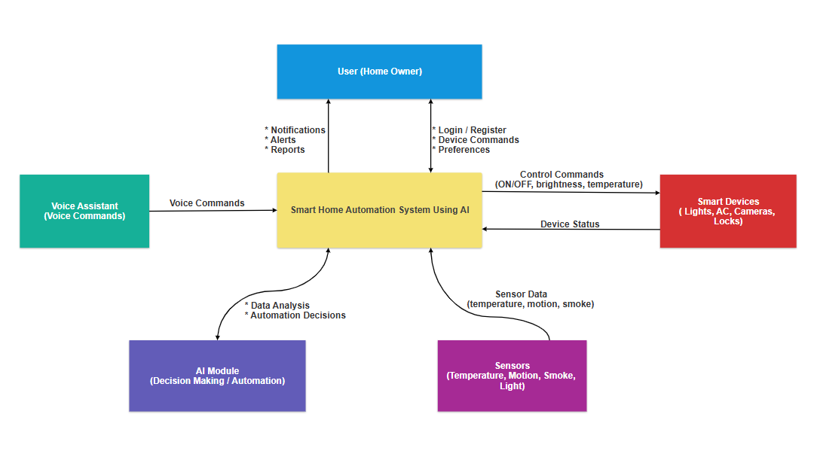
Figure 1 Context Diagram of the Smart Home Automation System Using AI

3.3 Use Case Diagrams
The use case diagram shows the main functions of the Smart Home AI system and how users, admin, AI, and voice assistant interact with it.
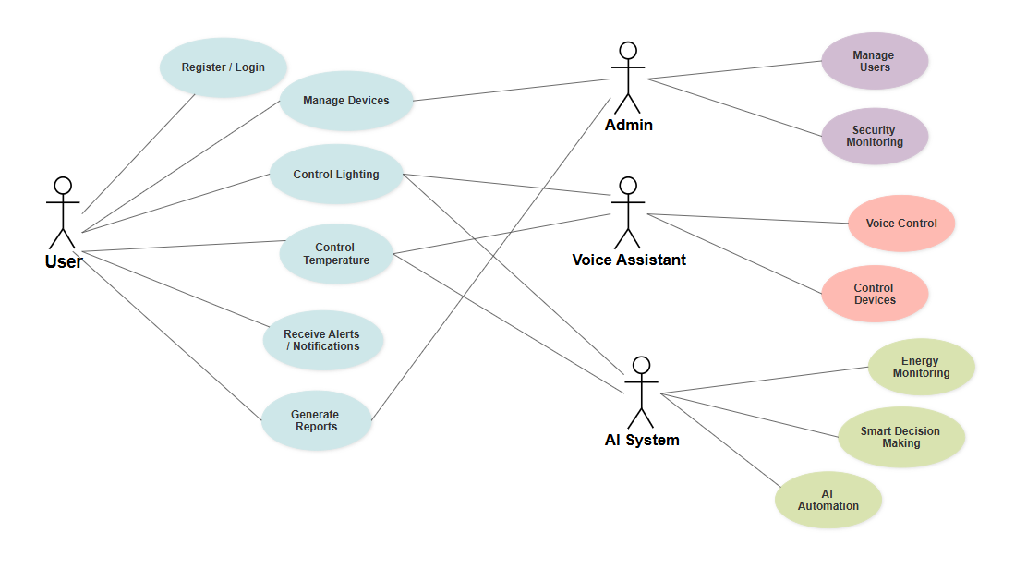
Figure 2 Smart Home Automation System Using AI use case diagram

3.4 Activity Diagrams – Flow Chart
The activity diagram illustrates how operations are performed by the user, admin, and AI system in the Smart Home Automation system.
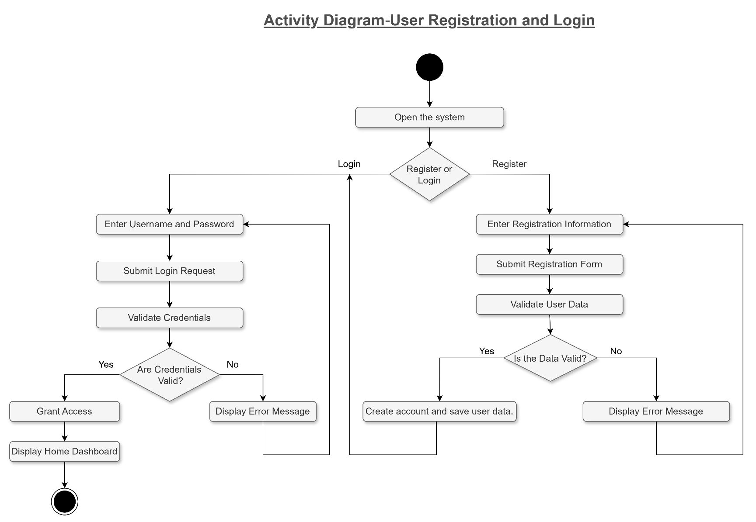

Figure 3 Activity Diagram-User Registration and Login

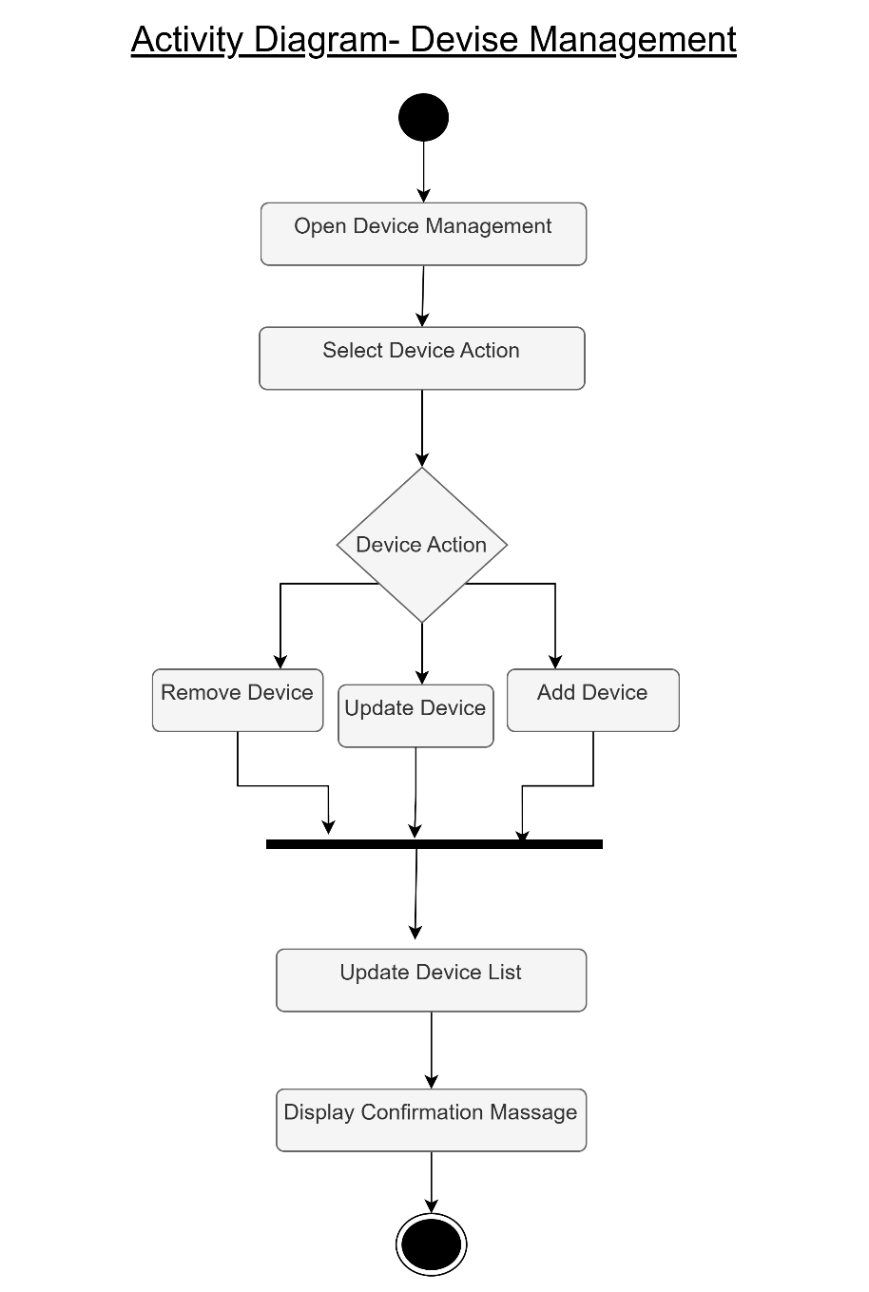
Figure 4 Activity Diagram- Devise Management

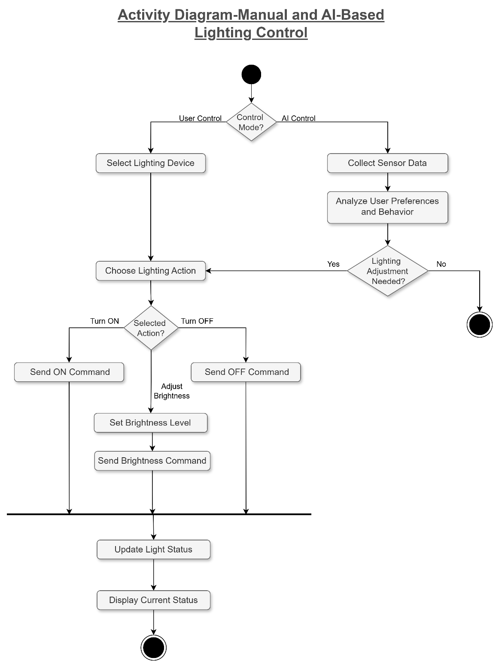
Figure 5 Activity Diagram-Manual and AI-Based Lighting Control

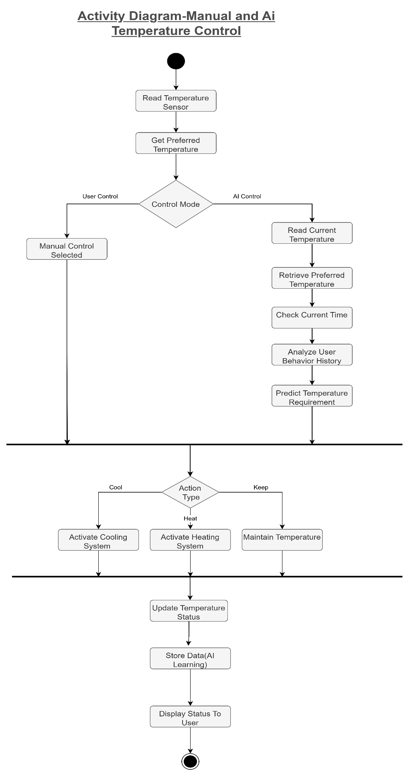
Figure 6 Activity Diagram-Manual and Ai Temperature Control

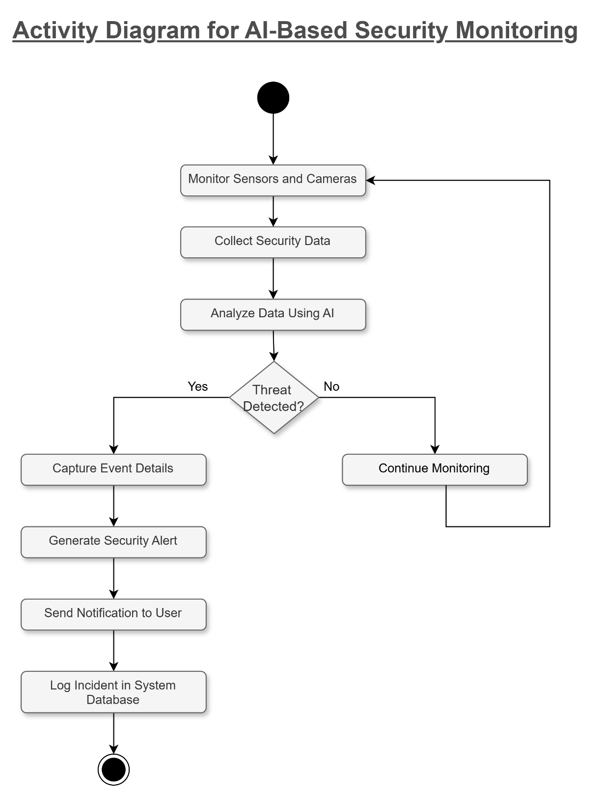
Figure 7 Activity Diagram for AI-Based Security Monitoring

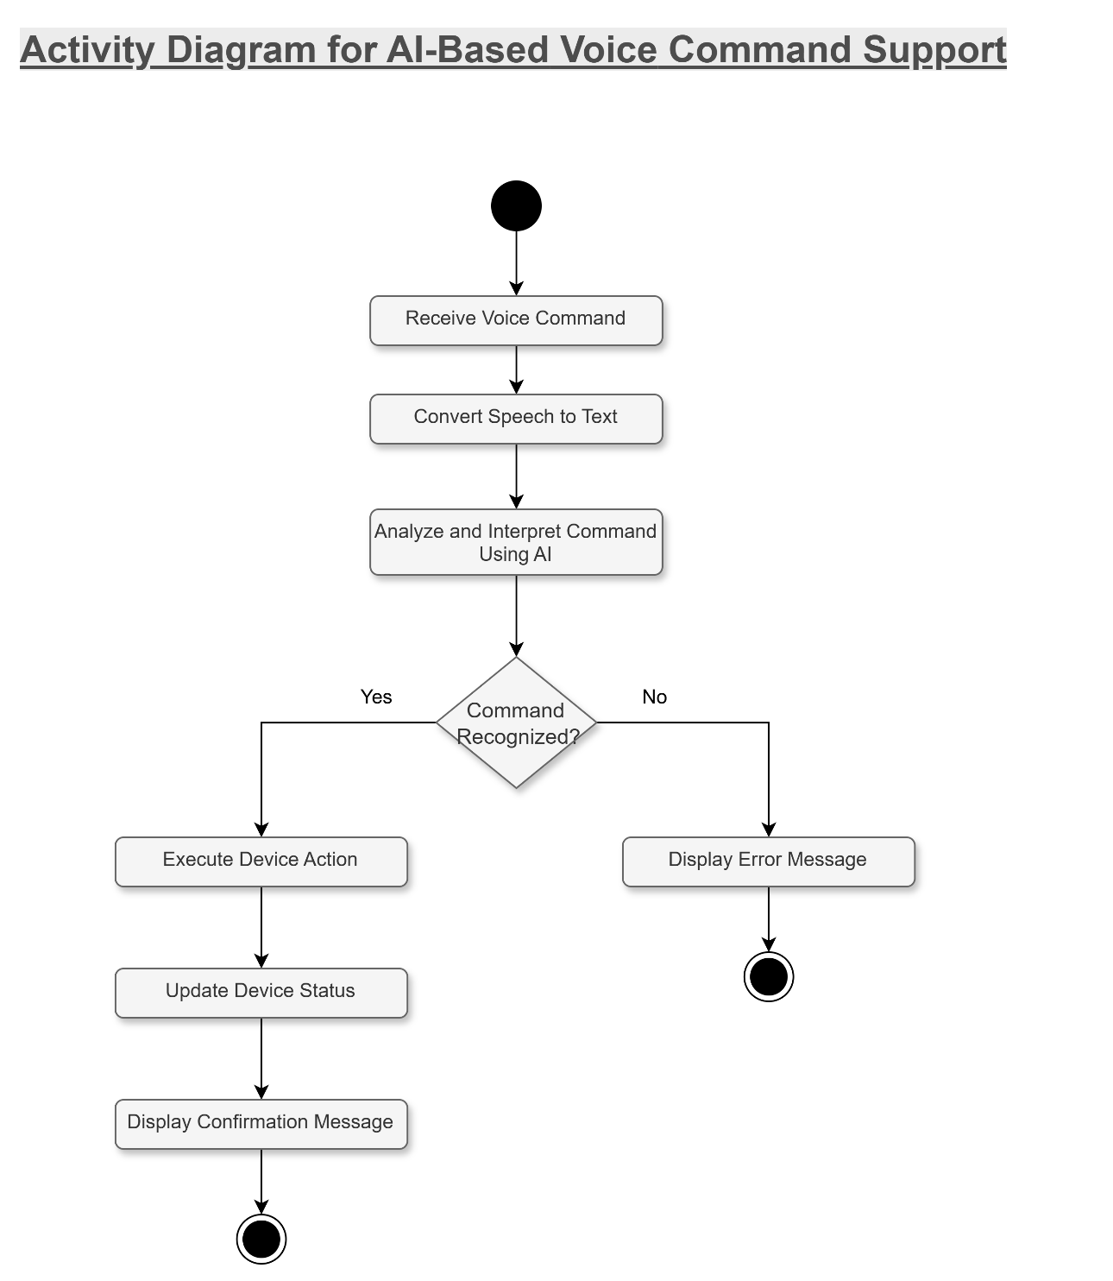

Figure 8 Activity Diagram for AI-Based Voice Command Support

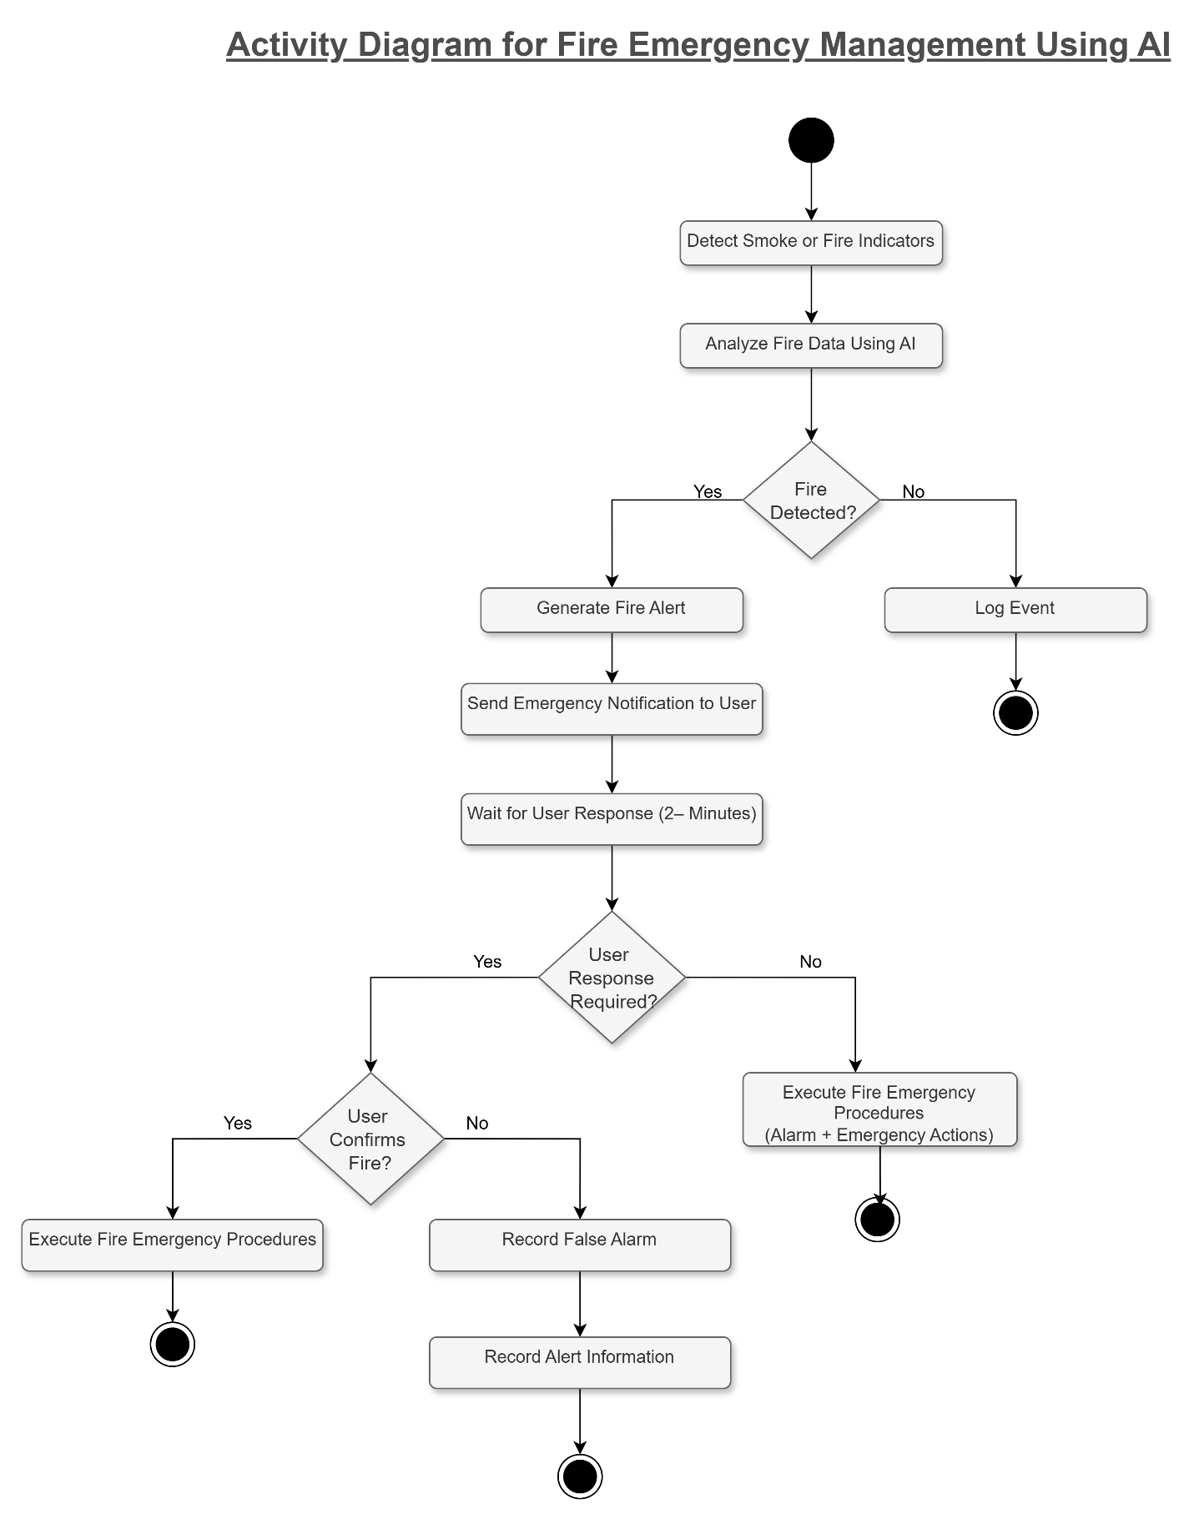

Figure 9 Activity Diagram for Fire Emergency Management Using AI

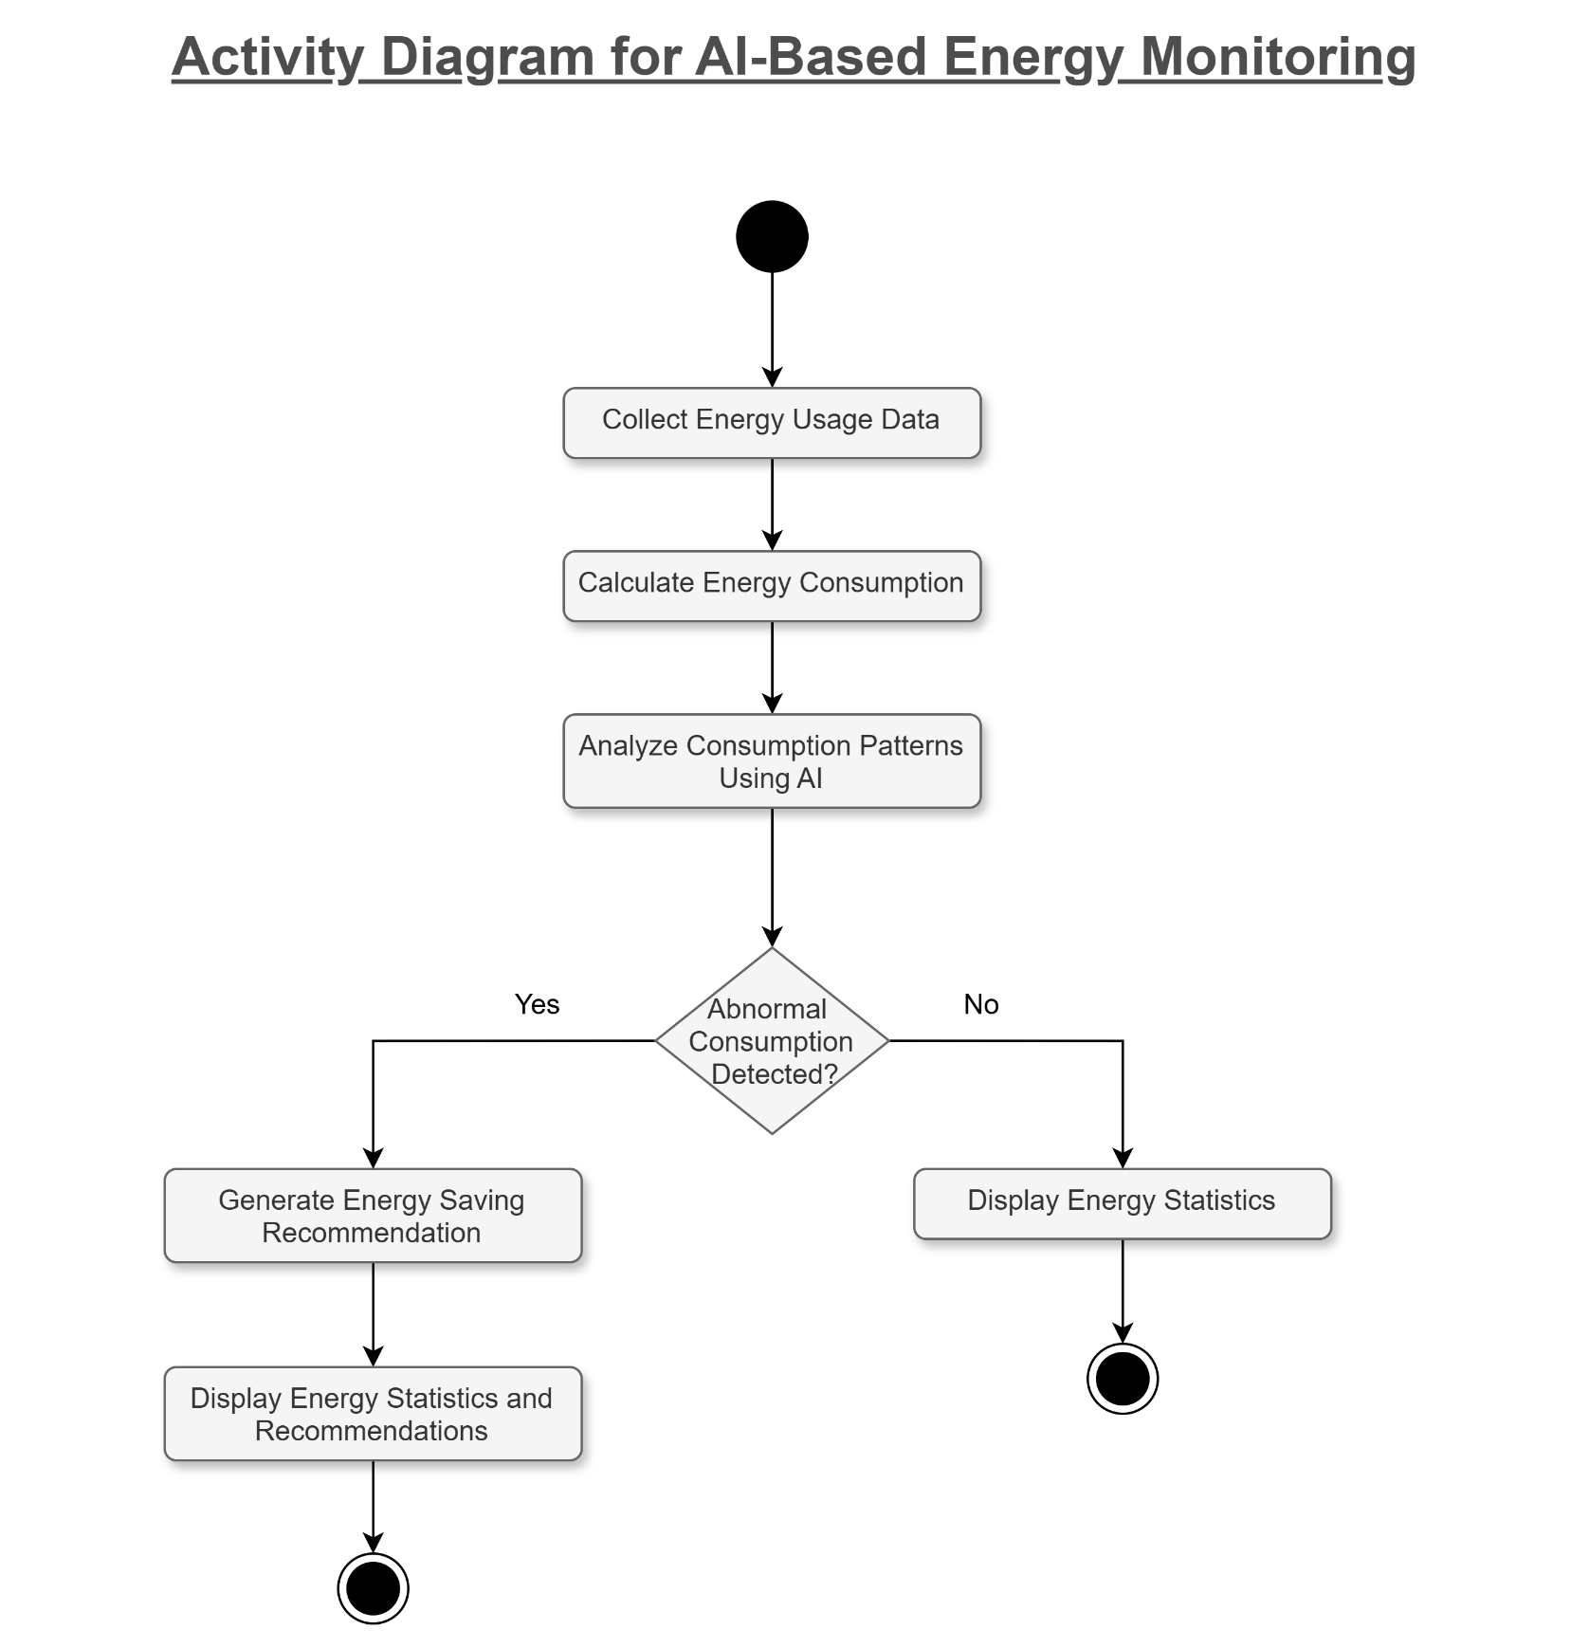
Figure 10 Activity Diagram for AI-Based Energy Monitoring

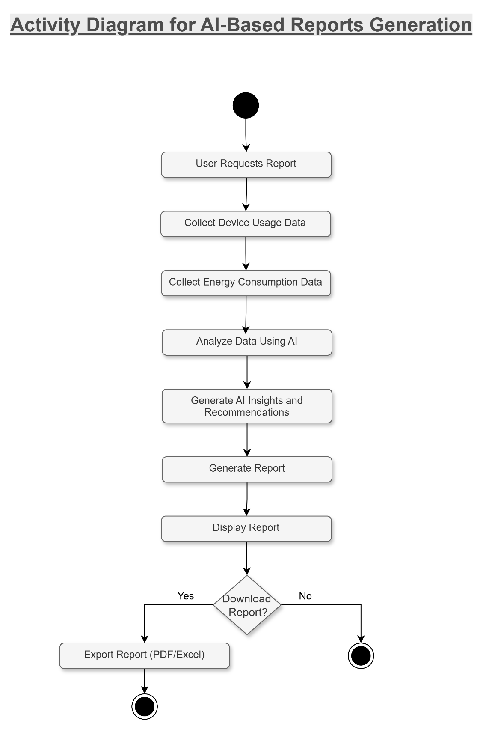

Figure 11 Activity Diagram for AI-Based Reports Generation

3.5 Sequence Diagrams
The Fourth diagram is the sequence diagram, which shows how the system interacts with users sequentially, step by step.
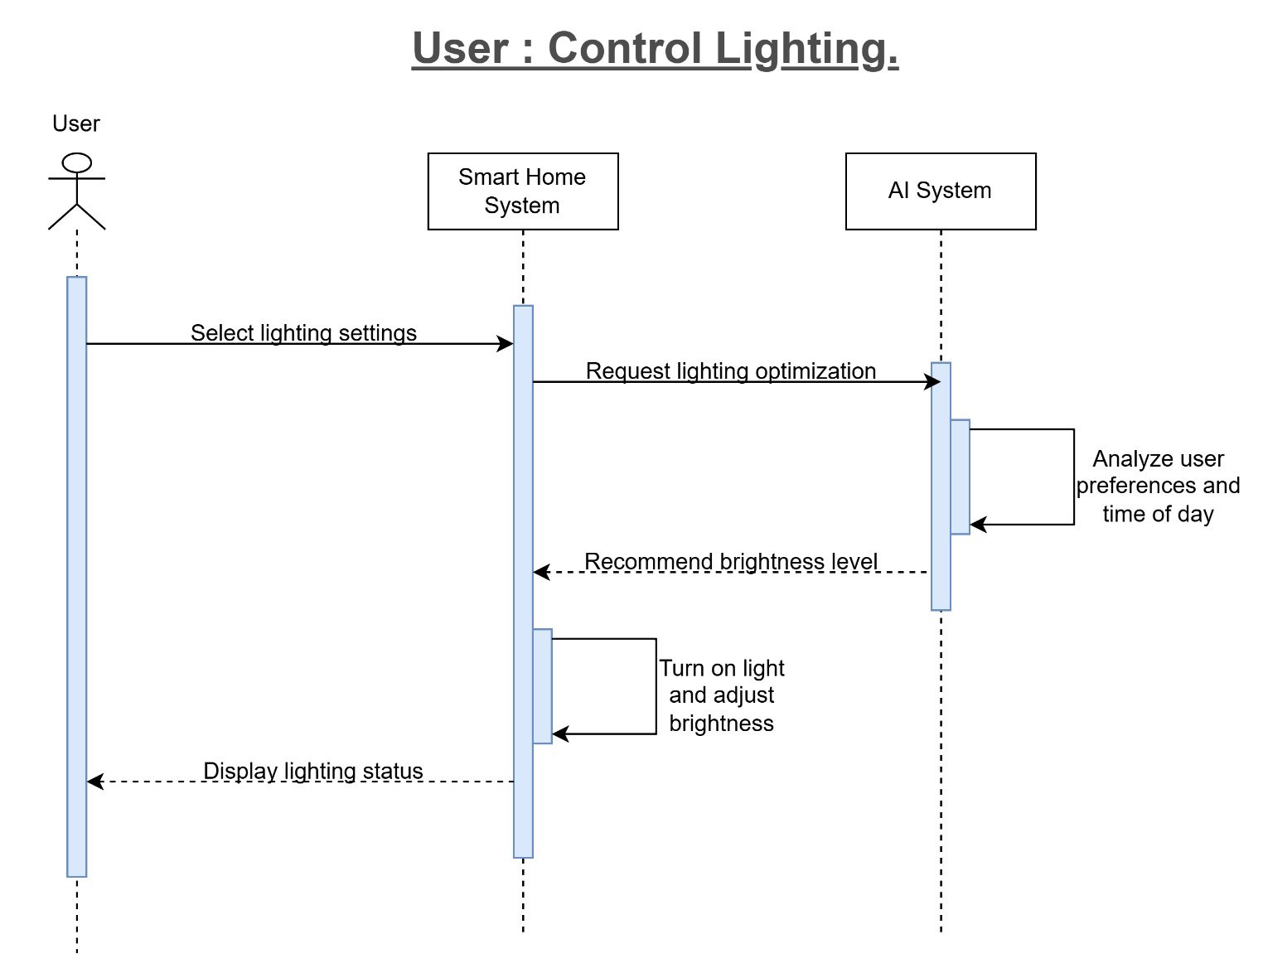
Figure 12 Sequence Diagram for User-Controlled Lighting

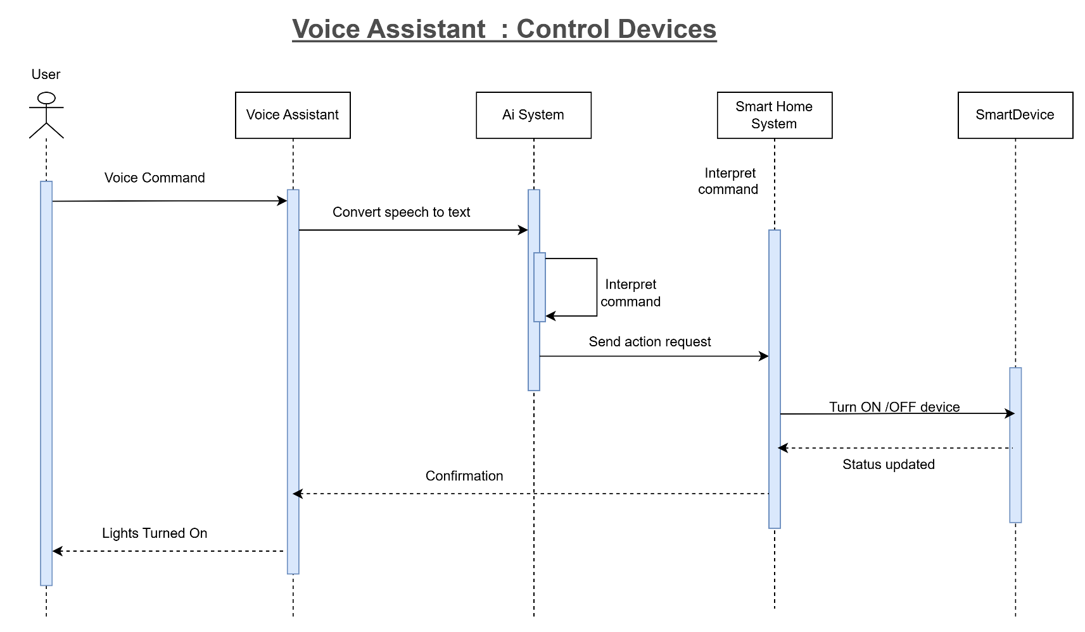
Figure 13 Sequence Diagram for Voice Assistant - Control Devices

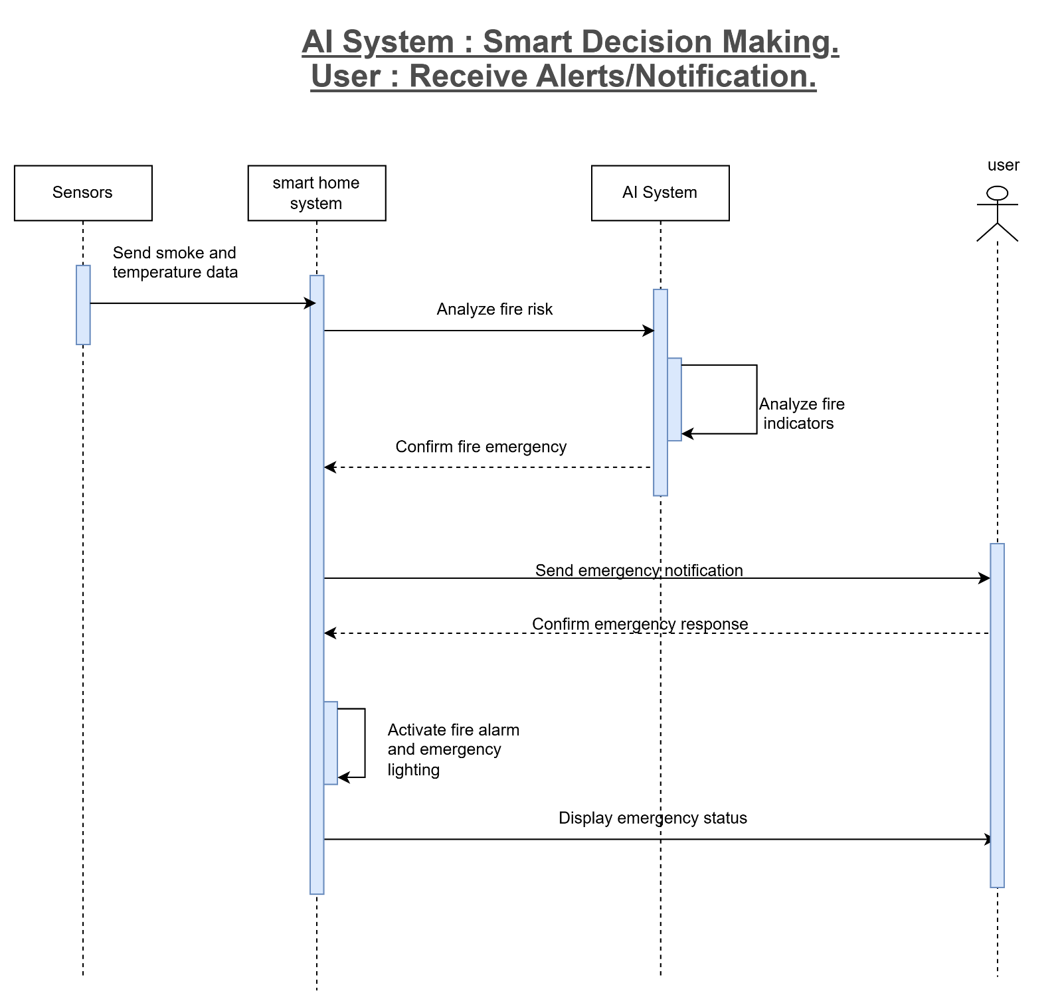

Figure 14 Sequence Diagram for AI System - Smart Decision Making and User - Receive Alerts/Notification.

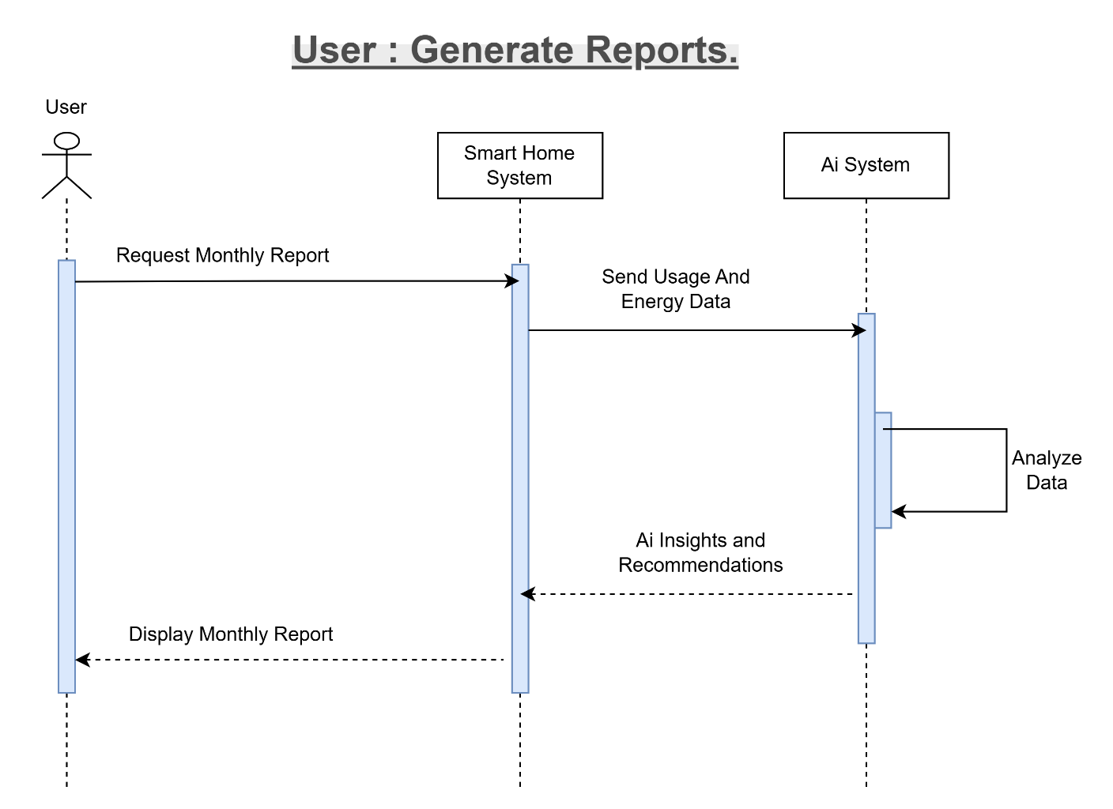

Figure 15 Sequence Diagram for User - Generate Reports.

3.6 Class Diagram
The Fifth diagram is the class diagram, shows the system's structure through three inputs: classes, properties, and relationships.
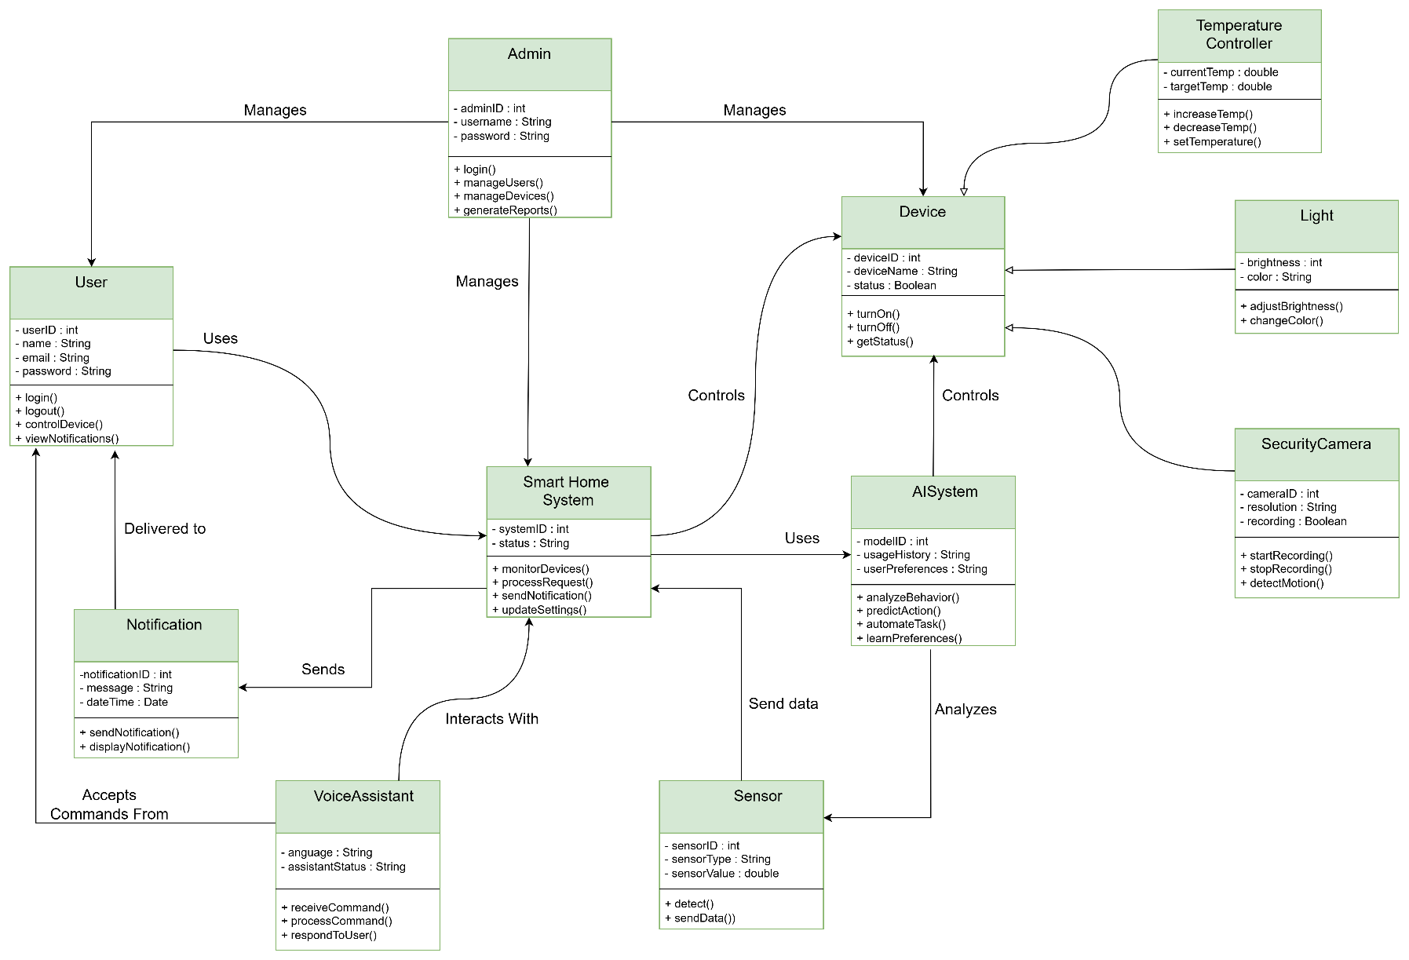

Figure 16 class diagram for the Smart Home Automation System Using AI .

3.7 Summary and Recommendations
This chapter presented the software design of the AI-Based Smart Home System. Several UML diagrams were developed to describe the system structure and behavior, including the Context Diagram, Use Case Diagram, Activity Diagrams, Sequence Diagrams, Class Diagram, and Entity Relationship Diagram (ERD). These diagrams provide a clear understanding of how users interact with the system, how data flows between components, and how AI supports automation, security monitoring, voice control, energy management, and report generation.
The design demonstrates that the system can effectively manage smart home devices, improve security through AI-based fire detection and alerts, support voice commands, monitor energy consumption, and generate intelligent reports. The database design also ensures efficient storage and management of system data.

Recommendations
* Implement advanced AI algorithms to improve prediction accuracy and automation decisions.
* Enhance security mechanisms by adding multi-factor authentication and data encryption.
* Integrate additional smart devices and sensors to increase system functionality.
* Develop a mobile application for easier remote access and control.
* Improve energy optimization features to reduce power consumption and operating costs.
* Continuously update the system based on user feedback and emerging smart home technologies.
This design provides a strong foundation for developing a reliable, secure, and intelligent smart home automation system.

